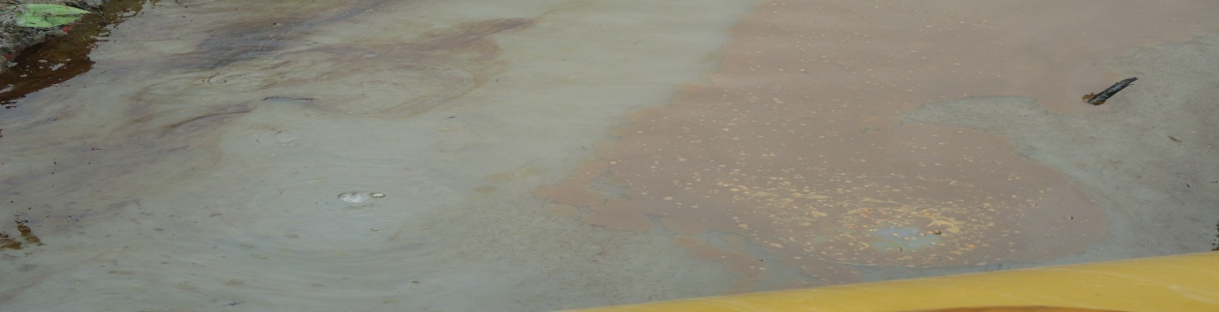
Spill point with crude oil bubbling before excavation during jiv.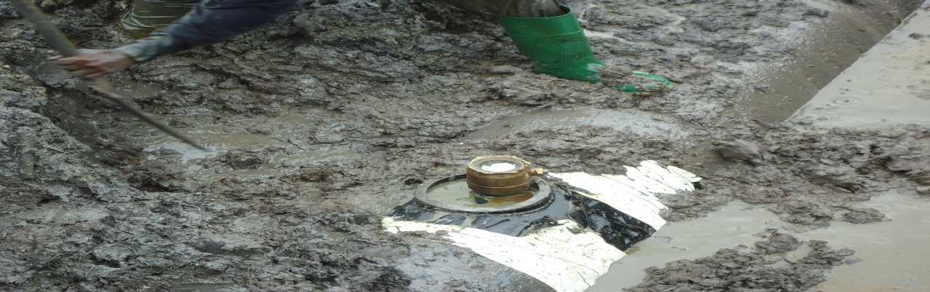
Spill point after exposing the pipe, showing the leak point with cut off cone.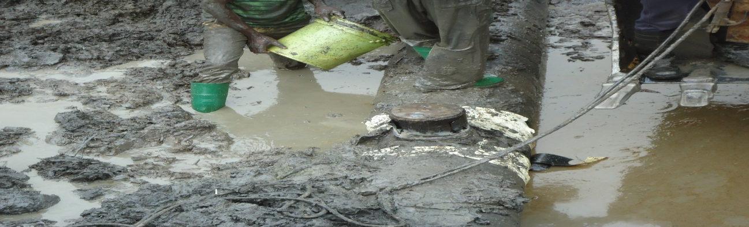 showing cone replaced during jiv.
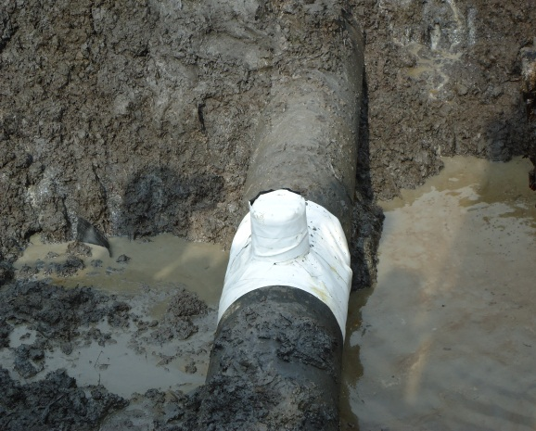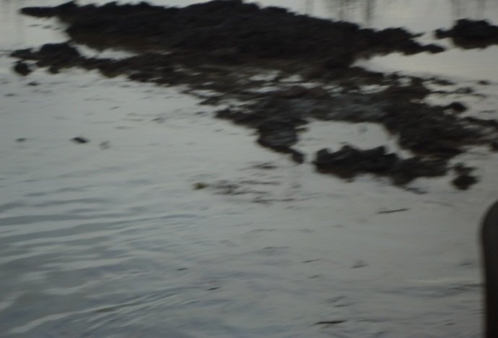
Pix showing pipeline after repair. Point after backfilling.

